## Create the Base Roads

1. Select the **Road** tool from the Roads tab and create a north-south road of 5 lanes. There will be 2 lanes in each direction (total 4) plus the 5th to act as the median strip.
2. With the Road tool still selected, create a 2-lane road to form a T intersection and extend as shown below.

* 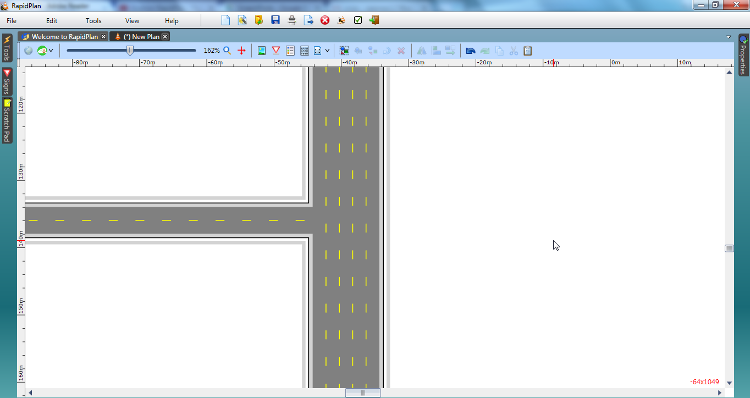
* Divided_Roads_Intersection_steps_1_and_2